* IMPORT LIBRARIES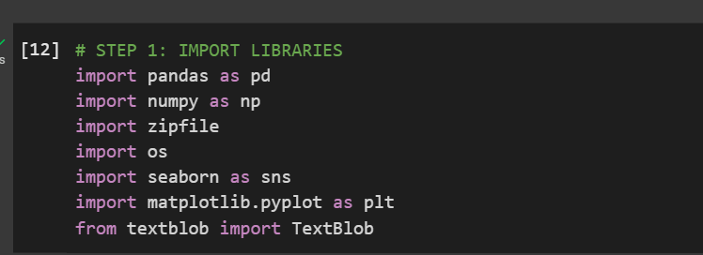
* UPLOAD AND READ DATASET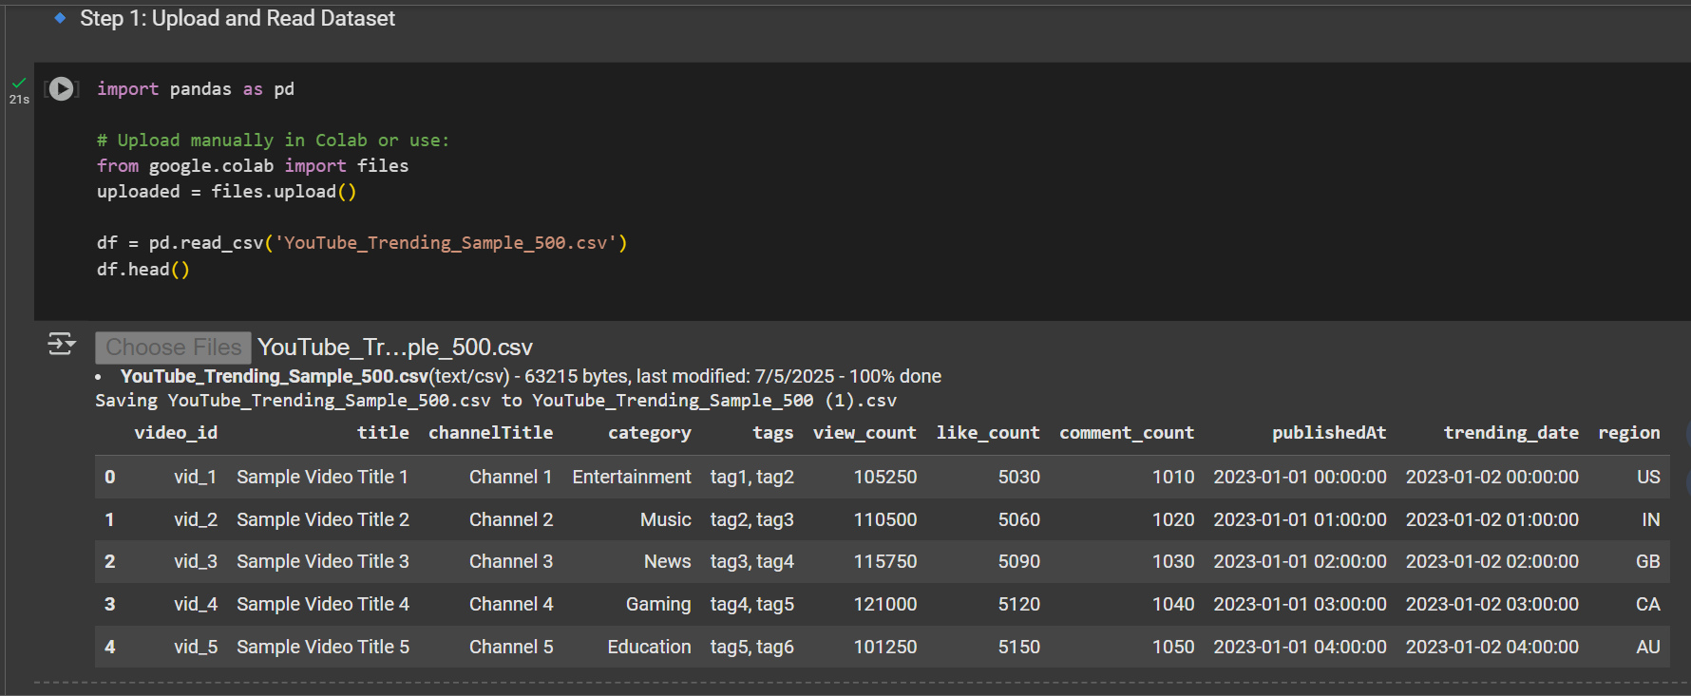
* DATA CLEANING
* 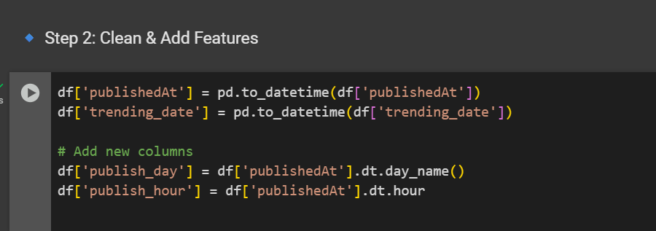
* DATA ANALYSIS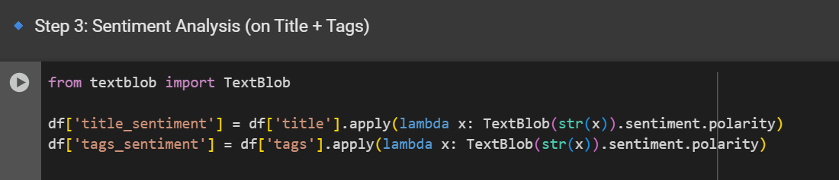
* SQL FOR FINDING TOP CATEGORIES BY AVERAGE VIEWS
* 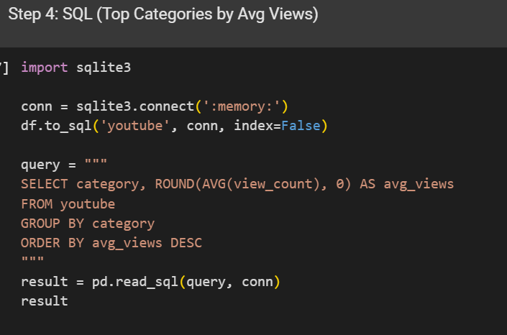

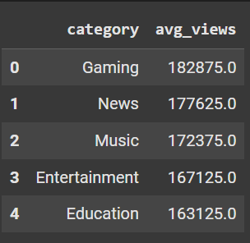

* EXPORT CSV FOR POWER BI

